Chapter 6, Solution 80.

From the given circuit,

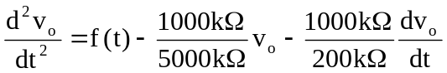

or

